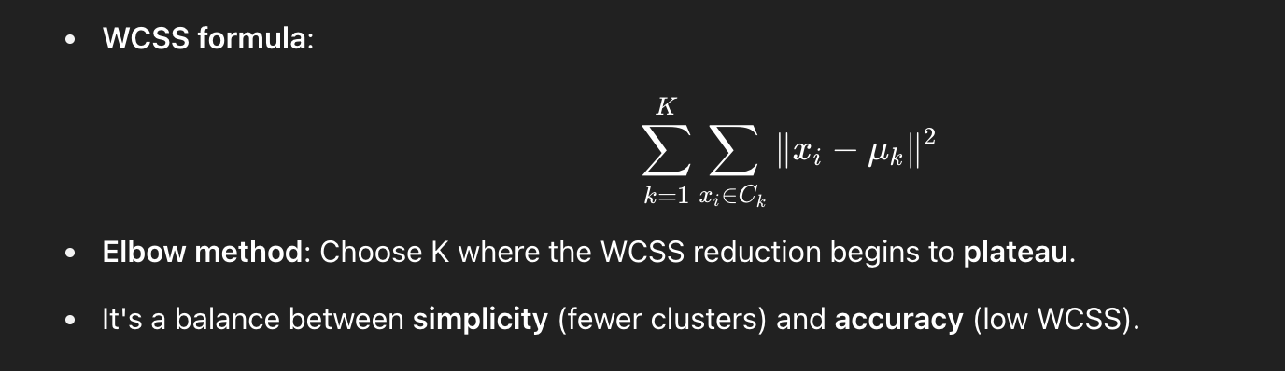

Let’s take 6 data points in 2D space:

A = (1, 2)

B = (1, 4)

C = (1, 0)

D = (10, 2)

E = (10, 4)

F = (10, 0)

You can already see that:

* A, B, C are close together
* D, E, F are another group  
  → likely **2 clusters**

**Step 1: Calculate WCSS for K = 1**

All points belong to one cluster.  
Find the **centroid**:

μ=(1+1+1+10+10+106,2+4+0+2+4+06)=(336,126)=(5.5,2)

Now compute squared distances of each point to the centroid:

* A = (1, 2):

∥A−μ∥2=(1−5.5)2+(2−2)2=20.25

* B = (1, 4):

(1−5.5)2+(4−2)2=20.25+4=24.25

* C = (1, 0):

(1−5.5)2+(0−2)2=20.25+4=24.25

* D = (10, 2):

(10−5.5)2+(2−2)2=20.25

* E = (10, 4):

(10−5.5)2+(4−2)2=20.25+4=24.25

* F = (10, 0):

(10−5.5)2+(0−2)2=20.25+4=24.25

**Total WCSS for K=1:**

20.25+24.25+24.25+20.25+24.25+24.25=137.5

**Step 2: Calculate WCSS for K = 2**

Group into two clusters:

* Cluster 1: A, B, C → mean = (1, (2+4+0)/3) = (1, 2)
* Cluster 2: D, E, F → mean = (10, (2+4+0)/3) = (10, 2)

**Cluster 1 (A, B, C):**

* A = (1, 2): distance to (1, 2) → 0
* B = (1, 4): → (4 - 2)^2 = 4
* C = (1, 0): → (0 - 2)^2 = 4  
  → WCSS = 0 + 4 + 4 = 8

**Cluster 2 (D, E, F):**

* D = (10, 2): distance to (10, 2) → 0
* E = (10, 4): → (4 - 2)^2 = 4
* F = (10, 0): → (0 - 2)^2 = 4  
  → WCSS = 0 + 4 + 4 = 8

**Total WCSS for K=2:**

8+8=16

**Step 3: Calculate WCSS for K = 3**

Split into 3 clusters:

* Cluster 1: A, B → centroid = (1, 3)
* Cluster 2: C → centroid = (1, 0)
* Cluster 3: D, E, F → centroid = (10, 2)

**Cluster 1 (A, B): mean = (1, 3)**

* A: (2 - 3)^2 = 1
* B: (4 - 3)^2 = 1  
  → WCSS = 2

**Cluster 2 (C): single point → WCSS = 0**

**Cluster 3: same as before → WCSS = 8**

**Total WCSS for K=3:**

2+0+8=10

**Elbow Table**

| **K** | **WCSS** |
| --- | --- |
| 1 | 137.5 |
| 2 | 16.0 |
| 3 | 10.0 |

**Conclusion**

* Big WCSS drop from K=1 to K=2.
* Smaller improvement from K=2 to K=3.

**Elbow is at K = 2**, so 2 clusters is optimal.